Let us visit Kyiv! /Complete with the question words: How? How many? What? Who? When? Why? Where?

Kyiv is the capital of Ukraine. It is the biggest city in Ukraine. It is more than 1500 years old. A chestnut leaf is a symbol of the city.  1. _______old is Kyiv?  2. __is symbol of the city? | 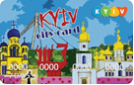 More than 3 millon people live there. There are more than 30 museums, about 200 monuments, 33 theatres.  3. ____people live there? | 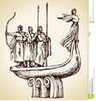Kyiv was founded / був заснований/ by three brothers Kyi, Shchek and Khoryv, and their sister Lybid. | 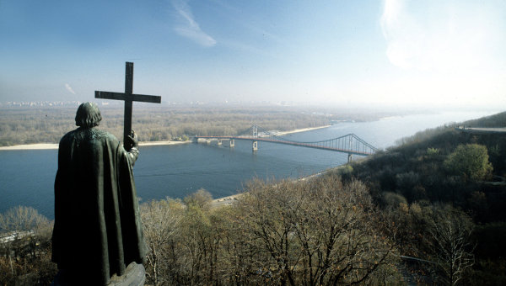 There is a monument to Prince Volodymyr who baptized |bæpˈtaɪzd| /хрестив/ Kyiv Rus. It is in the on the Dnipro hill.  4. __ baptized Kyiv Rus?
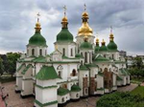 Saint Sophia Cathedral is the oldest cathedral in Ukraine It was founded in the 11th century by the Kyivan Prince Yaroslavl the Wise. 5. ____ is the oldest cathedral in Ukraine?  6. _____was St Sophia Cathedral founded? | 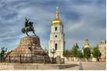 St Sophia Cathedral has the biggest bell in Ukraine of 13 tones on the bell tower of 76 meters! There is the Monument to Bogdan Khmelnitsky at Sophia Square.  7. ____ is the Monument to Bogdan Khmelnitsky? | 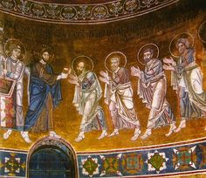 St Sophia Cathedral is famous for its beautiful mosaics and fresco- es. There are the tombs|tuːmz| /гробниці/ of Yaroslav the Wise and other Kyyivan Princes.  8. ___ is St Sophia Cathedral famous for? | 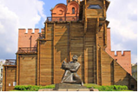  The Golden Gate is a monument from the 11th century. It is a museum with the monument to Yaroslav the Wise in front.  9. _____is the Golden Gate?
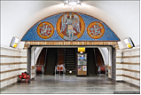 Kyiv metro station “Zoloti Vorota” is one of the most beautiful metro stations in the world! | 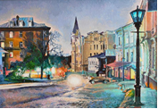The historical heart |hɑːt|/ серце/ of the city is Podil. Andrew Descent |dɪˈsent| /Андріївский узвіз/ is a street and the museum.  10. ____is the historical heart of the city? | 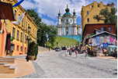 Andrew Descent is very popular with tourists, they can buy Ukrainian souvenirs of art and crafts /cувеніри з мистецтва і ремесел/.  11. ____ is Andrew Descent very popular with tourists? | 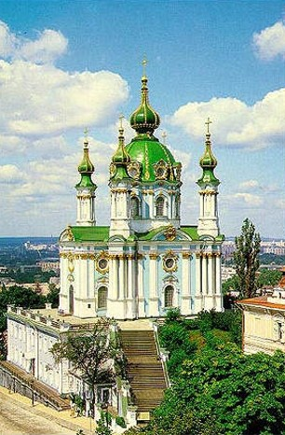In Podil you can see one of the most beautiful churches in Kyiv– Saint Andrew Church.
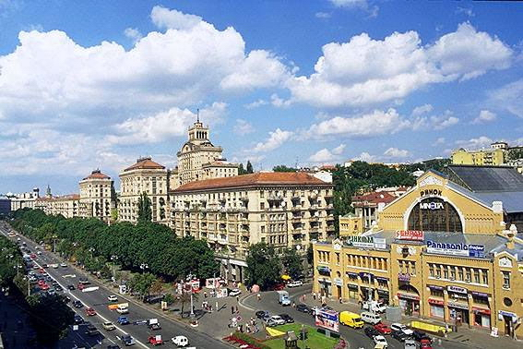 Khreshchatyk street is the main /oсновний/ street of Kyiv. On Saturdays and Sundays there is no traffic in this street.  12. ____ is the main street of Kyiv? | 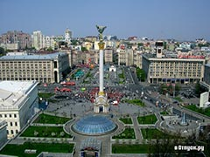 People have national celebrations and holiday events|ɪˈvents| /події/ on Independence Square.  13. _____do people have national celebrations and holiday events? | 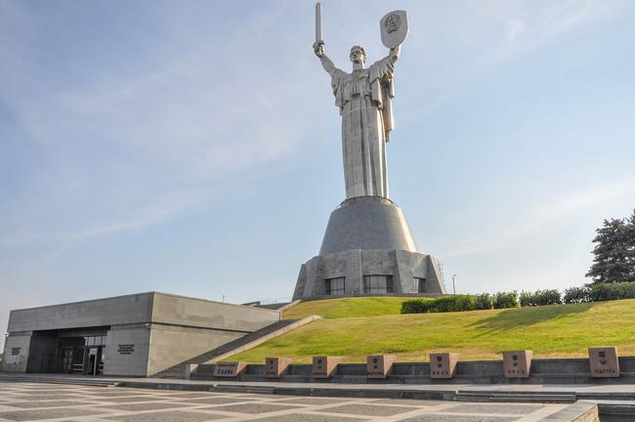 Mother -land Statue is one of the biggest monuments in the world. It is 102 meters high!  14.___is Motherland Statue one of the biggest monuments in the world? | 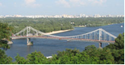  Pedestrian /Пішохідний/ bridge over the Dnipro river is the longest pedestrian bridge of Europe! It is 400 meteres long.  15. ____ long is Pedestrian bridge?
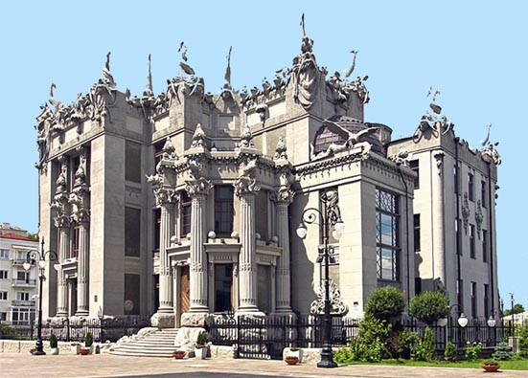The House with Chimeras /kaɪˈmɪərəz/ was designed by the architect |ˈɑːrkɪtekt| V. Horodetskiy in 1902. It is now a Presidential Administration Building.  16. ____ was the House with Chimeras designed? | 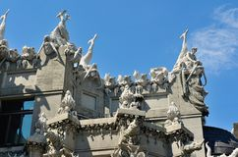 The architect liked hunting. So he decorated the House with exotic animals and other creatures |ˈkriːtʃəz|/істоти/.  17. _____ did the architect decorate the House with the exotic animals? | True or False?  1. Kyiv is the biggest city in Europe.  2. There are 30 museums, about 200 monuments, 33 theatres in Kyiv.  3. Kyiv was founded by Prince Volodymyr.  4. St Sophia Cathedral has the biggest bell tower in Ukraine.  5. There is the tomb of Yaroslav the Wise in the Golden Gate. | 6. “Zoloti Vorota” is one of the most beautiful metro stations in Kyiv.  7. Saint Andrew Church is the most beautiful church.  8. There is no traffic in Khreshchatyk street.  9. Pedestrian bridge over the Dnipro river is the longest pedestrian bridge of Ukraine.  10. The House with Chimeras is a museum.

